Toxic Comment Detection
Project Report — Brazilian Portuguese NLP Classification
Student: Rimi Das
Dataset: comentarios_toxicos_ptBR
Model: Logistic Regression + TF-IDF
Language: Brazilian Portuguese (pt-BR)

1. Problem Statement
Online platforms face significant challenges in managing harmful and offensive content. Toxic comments — including hate speech, insults, threats, and obscenities — degrade the quality of public discourse, discourage participation, and can cause real psychological harm to users. Manual moderation does not scale to the volume of user-generated content produced daily.
This project addresses the challenge of automatic toxic comment detection in Brazilian Portuguese. Using a labelled dataset of ~30,000 social-media comments, we train a machine learning classifier to predict whether a comment is toxic (label=1) or non-toxic (label=0), and expose the model through a REST API and an interactive web interface.

2. Dataset Description
The dataset `comentarios_toxicos_ptBR.csv` was sourced from publicly available Brazilian social-media and Twitter data. Each row represents a single user comment with the following columns:
Column | Type | Description
text | str | Raw user comment (original text)
text_norm | str | Pre-normalised version of the comment
toxic | int64 | Binary label: 1 = Toxic, 0 = Non-Toxic

Key Statistics:
• Total rows (after cleaning): 29,686
• Non-toxic comments (label=0): 16,286 (54.9%)
• Toxic comments (label=1): 13,400 (45.1%)
• Null values in 'text': 1 (dropped)
• Duplicate rows removed: 235
• Language: Brazilian Portuguese (pt-BR)

3. Methodology

3.1 Text Preprocessing Pipeline
- Lowercase conversion
- URL removal (http/https links stripped)
- Mention removal (@user tokens removed)
- Hashtag removal (#topic tokens removed)
- Digit removal
- Punctuation removal
- Stopword removal (custom Portuguese stopword list, 70+ entries)
- Short token filtering (tokens with length ≤ 2 removed)

3.2 Feature Engineering
Text features were extracted using the TF-IDF (Term Frequency–Inverse Document Frequency) vectorizer with the following configuration:
• max_features = 20,000
• ngram_range = (1, 2) [unigrams + bigrams]
• min_df = 2 [ignore terms appearing in fewer than 2 documents]
• sublinear_tf = True [apply log(1 + tf) scaling]

3.3 Classifier
A Logistic Regression classifier was selected for its interpretability, efficiency on sparse TF-IDF features, and strong baseline performance on text classification tasks. Configuration: C=1.0, solver='lbfgs', max_iter=1000, class_weight='balanced', random_state=42.
The 'balanced' class weight was used to compensate for the slight class imbalance (16,286 non-toxic vs 13,400 toxic comments).

3.4 Train/Test Split
The dataset was split 80/20 with stratification to preserve class ratios: 23,748 training samples and 5,938 test samples.

4. Exploratory Data Analysis (EDA) Findings
The EDA revealed the following insights about the dataset:
- The dataset is moderately imbalanced: 54.9% non-toxic vs 45.1% toxic comments.
- Toxic comments tend to be slightly shorter on average than non-toxic ones.
- Top toxic words are predominantly profanity and insults in Brazilian Portuguese slang.
- Comment lengths are right-skewed, with the majority of comments under 200 characters.
- The 'text_norm' column provides a useful normalised alternative but contains 53 nulls, so raw 'text' was used.

Figure 1: Class Distribution
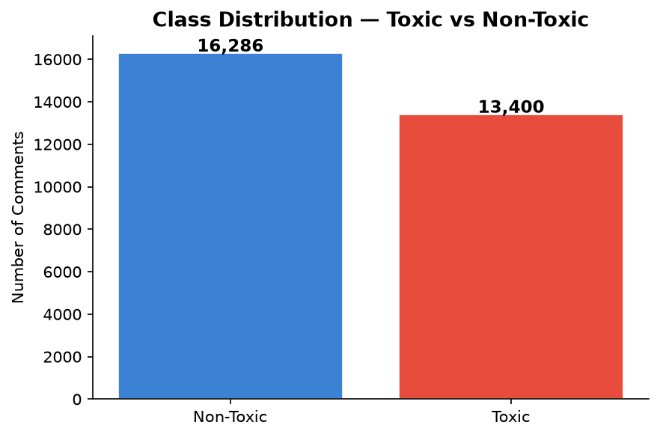

Figure 2: Comment Length Distribution
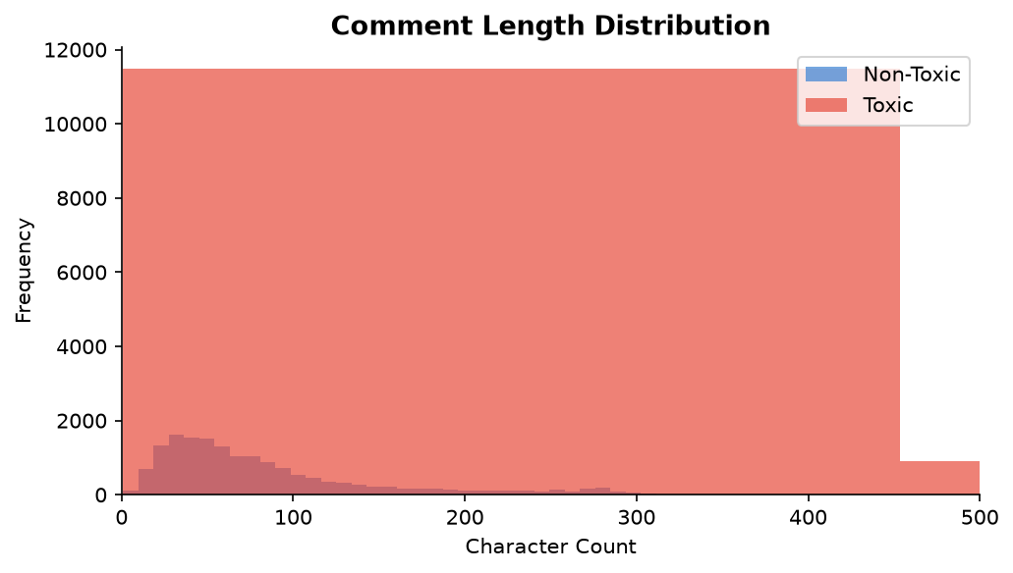

Figure 3: Top 20 Toxic Words
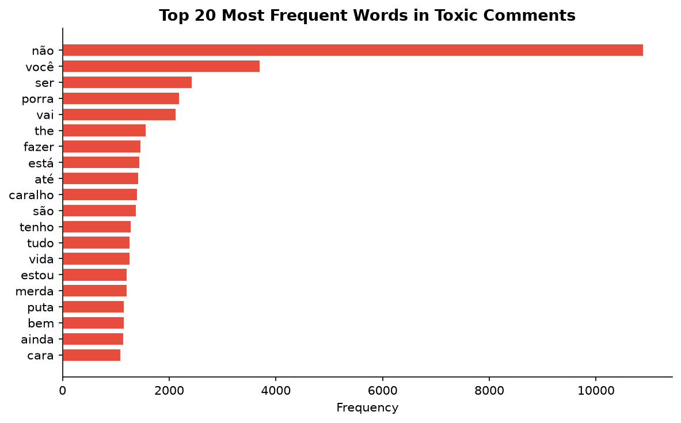

5. Model Results & Metrics
After training on 23,748 samples and evaluating on 5,938 held-out samples, the Logistic Regression model achieved the following performance metrics:
Metric | Score
Accuracy | 0.7695 (76.95%)
Precision | 0.7449 (74.49%)
Recall | 0.7440 (74.40%)
F1-Score | 0.7444 (74.44%)

Figure 4: Confusion Matrix
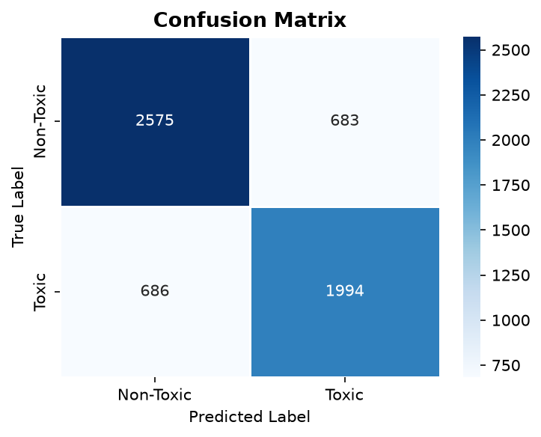

Confusion Matrix Breakdown
 | Predicted Non-Toxic | Predicted Toxic
Actual Non-Toxic | TP = 2,575 (Correct) | FP = 683 (False Alarm)
Actual Toxic | FN = 686 (Missed) | TN = 1,994 (Correct)

Figure 5: Evaluation Metrics Bar Chart
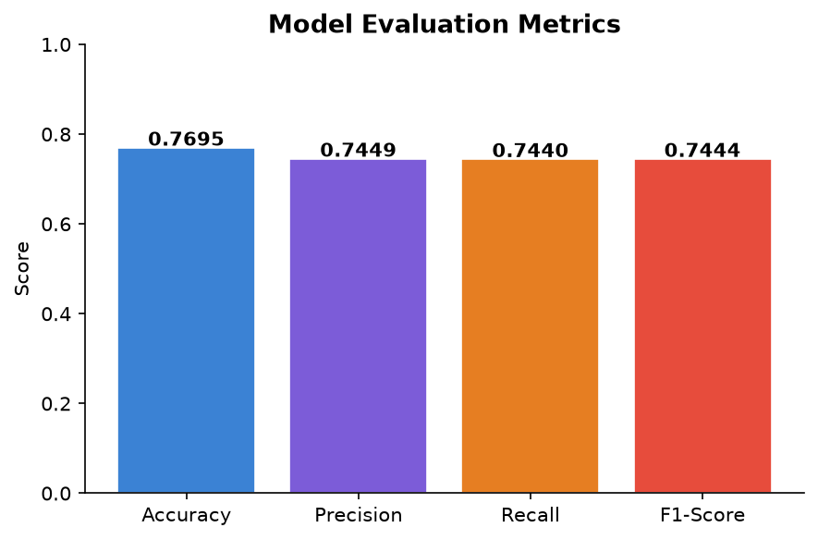

6. Flask REST API
A RESTful API was built using Flask to expose the trained model for real-time inference. The API loads the saved model and vectorizer at startup and provides the following endpoints:
Endpoint | Description
GET /health | Returns service status
GET /model-info | Returns model details and all evaluation metrics
POST /predict | Accepts a single comment and returns label + probabilities
POST /predict-batch | Accepts a list of comments and returns predictions for each

Sample API Response (/predict):
{
"comment": "Cala a boca seu burro inutil",
"label": "Toxic",
"prediction": 1,
"probability": {
"non_toxic": 0.0627,
"toxic": 0.9373
}
}

Figure 6: Sample API Prediction Results
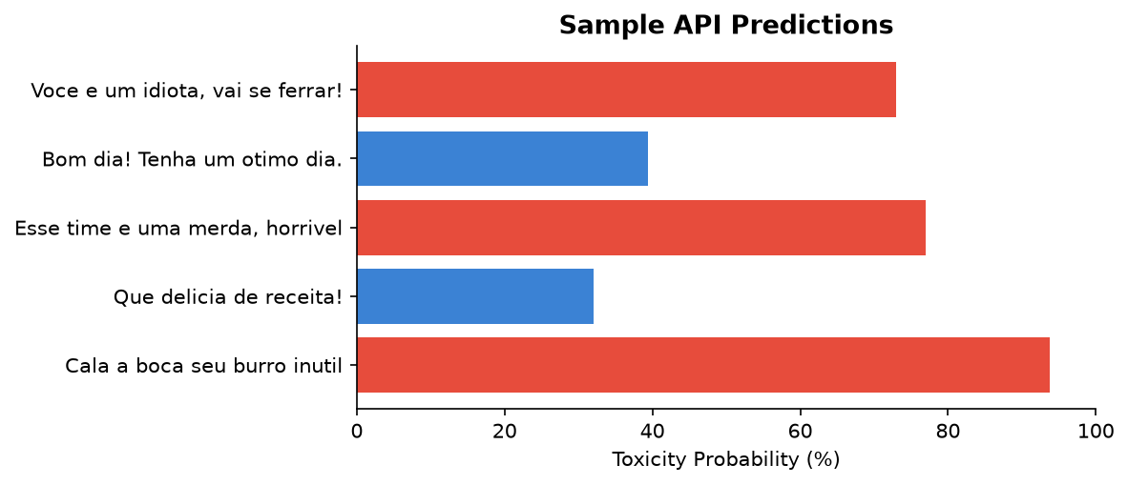

7. Streamlit Frontend
An interactive web frontend was built using Streamlit (`ui.py`), providing:
- 🔍 Predict page — Enter any comment and get real-time toxicity prediction with probability bar
- 📊 Dashboard page — Interactive EDA charts: class distribution, length histogram, top toxic words
- ℹ️ Model Info page — Live metrics from the Flask API, confusion matrix heatmap
- Batch prediction support — Upload or paste multiple comments at once
To run: streamlit run frontend/ui.py

8. Conclusion
This project successfully built an end-to-end toxic comment detection system for Brazilian Portuguese social-media content. The Logistic Regression classifier, trained on 29,686 cleaned comments with TF-IDF features, achieved an accuracy of 76.95%, F1-score of 74.44%, precision of 74.49%, and recall of 74.40% on the held-out test set.
Key takeaways:
- TF-IDF with unigrams and bigrams provides a strong feature space for short social-media text.
- Logistic Regression with balanced class weights handles moderate class imbalance well.
- The Flask REST API enables real-time inference, and the Streamlit UI makes the model accessible to non-technical users.
- Future improvements could include transformer-based models (e.g., BERTimbau) for higher accuracy, or fine-grained toxicity categories (threat, insult, obscene).

9. Technology Stack
Layer | Technology / Library
Language | Python 3.x
ML / NLP | scikit-learn, TF-IDF, Logistic Regression
Data | pandas, numpy
Visualisation | matplotlib, seaborn
Backend API | Flask
Frontend | Streamlit
Persistence | joblib (.pkl files), JSON

Generated by Rimi Das | Toxic Comment Detection Project | IBM Project Submission

